Thư mục sẽ bao gồm như hình bên dưới sau:

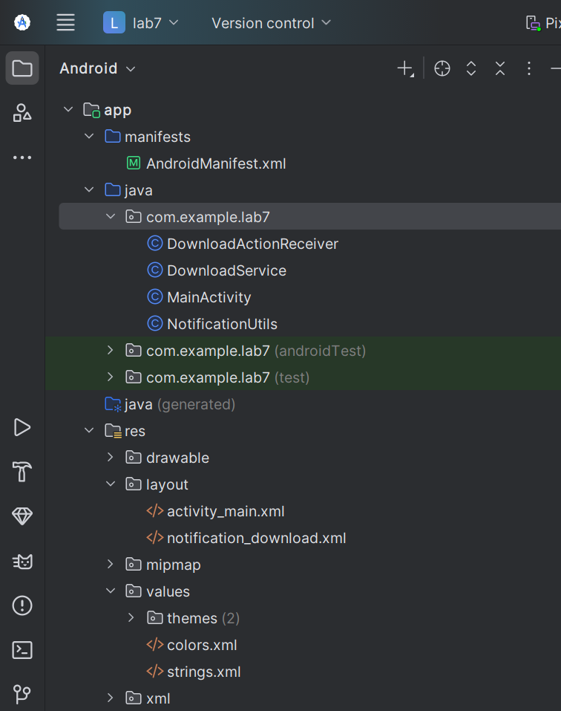

Bước 1: Tạo project mới → Empty Activity (Java).

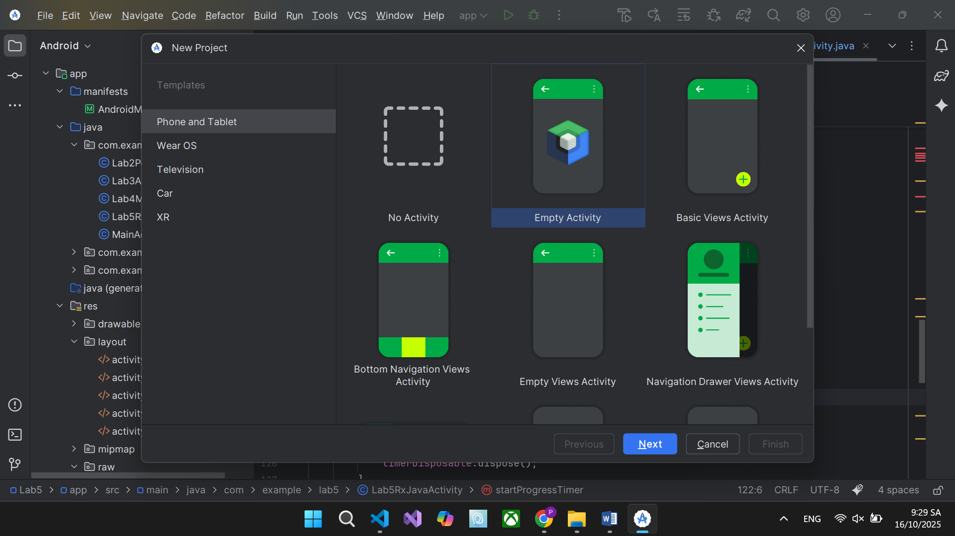

- Trong AndroidManifest.xml thêm quyền:

<uses-permission android:name="android.permission.INTERNET" />

Bước 2 :Tạo class tiện ích để tạo channel. Gọi khi app khởi động (MainActivity.onCreate):

package com.example.lab7;  
  
import android.app.NotificationChannel;  
import android.app.NotificationManager;  
import android.content.Context;  
import android.os.Build;  
  
public class NotificationUtils {  
 public static final String *CHANNEL_ID* = "download_channel";  
  
 public static void createChannel(Context context) {  
 if (Build.VERSION.*SDK_INT* >= Build.VERSION_CODES.*O*) {  
 NotificationChannel channel = new NotificationChannel(  
 *CHANNEL_ID*,  
 "Download Channel",  
 NotificationManager.*IMPORTANCE_LOW* );  
 channel.setDescription("Hiển thị tiến trình tải file");  
 NotificationManager manager = context.getSystemService(NotificationManager.class);  
 manager.createNotificationChannel(channel);  
 }  
 }  
}

- Gọi hàm này 1 lần duy nhất trong MainActivity.onCreate() để tạo channel trước khi hiển thị thông báo.

Bước 3: Ta tạo layout cho phần thông báo res/layout/activity_main.xml

<?xml version="1.0" encoding="utf-8"?>  
<LinearLayout xmlns:android="http://schemas.android.com/apk/res/android"  
 android:layout_width="match_parent"  
 android:layout_height="match_parent"  
 android:orientation="vertical"  
 android:gravity="center"  
 android:padding="20dp">  
  
 <EditText  
 android:id="@+id/edtUrl"  
 android:layout_width="match_parent"  
 android:layout_height="wrap_content"  
 android:hint="Nhập link tải"  
 android:inputType="textUri" />  
  
 <Button  
 android:id="@+id/btnDownload"  
 android:layout_width="match_parent"  
 android:layout_height="wrap_content"  
 android:text="Tải File"  
 android:layout_marginTop="20dp" />  
  
 <ProgressBar  
 android:id="@+id/progressBar"  
 android:layout_width="match_parent"  
 android:layout_height="wrap_content"  
 style="?android:attr/progressBarStyleHorizontal"  
 android:max="100"  
 android:layout_marginTop="20dp"/>  
  
</LinearLayout>

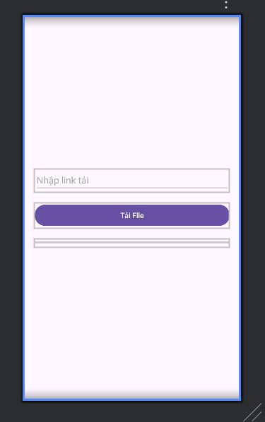

- Mục MainActivity.java ta thêm đoạn code sau vào

package com.example.lab7;  
  
import androidx.appcompat.app.AppCompatActivity;  
import android.os.Bundle;  
import android.widget.*;  
import android.content.*;  
import android.os.Build;  
  
public class MainActivity extends AppCompatActivity {  
 private EditText edtUrl;  
 private ProgressBar progressBar;  
 private Button btnDownload;  
  
 private BroadcastReceiver progressReceiver = new BroadcastReceiver() {  
 @Override  
 public void onReceive(Context context, Intent intent) {  
 int progress = intent.getIntExtra("progress", 0);  
 progressBar.setProgress(progress);  
 }  
 };  
  
 @Override  
 protected void onCreate(Bundle savedInstanceState) {  
 super.onCreate(savedInstanceState);  
 setContentView(R.layout.*activity_main*);  
  
 NotificationUtils.*createChannel*(this);  
  
 edtUrl = findViewById(R.id.*edtUrl*);  
 progressBar = findViewById(R.id.*progressBar*);  
 btnDownload = findViewById(R.id.*btnDownload*);  
  
 btnDownload.setOnClickListener(v -> {  
 String url = edtUrl.getText().toString().trim();  
 if (url.isEmpty()) {  
 Toast.*makeText*(this, "Vui lòng nhập URL!", Toast.*LENGTH_SHORT*).show();  
 return;  
 }  
 Intent intent = new Intent(this, DownloadService.class);  
 intent.putExtra("url", url);  
  
 if (Build.VERSION.*SDK_INT* >= Build.VERSION_CODES.*O*)  
 startForegroundService(intent);  
 else  
 startService(intent);  
 });  
 }  
  
 @Override  
 protected void onResume() {  
 super.onResume();  
 registerReceiver(progressReceiver, new IntentFilter("DOWNLOAD_PROGRESS"));  
 }  
  
 @Override  
 protected void onPause() {  
 super.onPause();  
 unregisterReceiver(progressReceiver);  
 }  
}

Bước 4: BroadcastReceiver để nhận action từ Notification, mục DownloadActionReceiver.java ta thêm đoạn code dưới đây:

package com.example.lab7;  
  
import android.content.*;  
import android.os.Build;  
  
public class DownloadActionReceiver extends BroadcastReceiver {  
 public static final String *ACTION_PAUSE* = "ACTION_PAUSE";  
 public static final String *ACTION_RESUME* = "ACTION_RESUME";  
 public static final String *ACTION_CANCEL* = "ACTION_CANCEL";  
  
 @Override  
 public void onReceive(Context context, Intent intent) {  
 Intent svc = new Intent(context, DownloadService.class);  
 svc.setAction(intent.getAction());  
 if (Build.VERSION.*SDK_INT* >= Build.VERSION_CODES.*O*)  
 context.startForegroundService(svc);  
 else  
 context.startService(svc);  
 }  
}

- Ta khai báo trong AndroidManifest.xml

<receiver android:name=".DownloadActionReceiver">  
 <intent-filter>  
 <action android:name="ACTION_PAUSE" />  
 <action android:name="ACTION_RESUME" />  
 <action android:name="ACTION_CANCEL" />  
 </intent-filter>  
</receiver>

Bước 5: Ta thiết kế layout cho res/layout/notification_download.xml

<?xml version="1.0" encoding="utf-8"?>  
<LinearLayout xmlns:android="http://schemas.android.com/apk/res/android"  
 android:layout_width="match_parent"  
 android:layout_height="wrap_content"  
 android:orientation="vertical"  
 android:padding="8dp">  
  
 <TextView  
 android:id="@+id/tvTitle"  
 android:text="Downloading..."  
 android:textSize="16sp"  
 android:layout_width="wrap_content"  
 android:layout_height="wrap_content"/>  
  
 <ProgressBar  
 android:id="@+id/progressBar"  
 style="?android:attr/progressBarStyleHorizontal"  
 android:layout_width="match_parent"  
 android:layout_height="wrap_content"  
 android:max="100"/>  
  
 <LinearLayout  
 android:layout_width="match_parent"  
 android:layout_height="wrap_content"  
 android:orientation="horizontal"  
 android:gravity="end">  
 <Button android:id="@+id/btnPause" android:text="Pause"/>  
 <Button android:id="@+id/btnResume" android:text="Resume"/>  
 <Button android:id="@+id/btnCancel" android:text="Cancel"/>  
 </LinearLayout>  
</LinearLayout>

Bước 6: Đến mục DownloadService.java, đây là phần quan trọng nhất (service tải file + cập nhật thông báo), ta thêm code vào như dưới đây

package com.example.lab7;  
  
import android.net.Uri;  
import android.app.*;  
import android.content.*;  
import android.os.*;  
import android.widget.RemoteViews;  
import androidx.core.app.NotificationCompat;  
import androidx.core.app.NotificationManagerCompat;  
import java.io.*;  
import java.net.HttpURLConnection;  
import java.net.URL;  
  
public class DownloadService extends Service {  
 private static final int *NOTIF_ID* = 1;  
 private boolean isPaused = false;  
 private boolean isCanceled = false;  
 private File outputFile;  
  
 @Override  
 public int onStartCommand(Intent intent, int flags, int startId) {  
 NotificationUtils.*createChannel*(this);  
  
 String action = intent.getAction();  
 if (action != null) {  
 switch (action) {  
 case DownloadActionReceiver.*ACTION_PAUSE*:  
 isPaused = true;  
 return *START_STICKY*;  
 case DownloadActionReceiver.*ACTION_RESUME*:  
 isPaused = false;  
 return *START_STICKY*;  
 case DownloadActionReceiver.*ACTION_CANCEL*:  
 isCanceled = true;  
 stopSelf();  
 return *START_NOT_STICKY*;  
 }  
 }  
  
 String url = intent.getStringExtra("url");  
 if (url != null)  
 startForeground(*NOTIF_ID*, createNotification(0));  
  
 new Thread(() -> downloadFile(url)).start();  
  
 return *START_STICKY*;  
 }  
  
 private void downloadFile(String urlStr) {  
 try {  
 URL url = new URL(urlStr);  
 HttpURLConnection conn = (HttpURLConnection) url.openConnection();  
 conn.connect();  
  
 String fileName = Uri.*parse*(urlStr).getLastPathSegment();  
 outputFile = new File(getFilesDir(), fileName);  
 InputStream in = conn.getInputStream();  
 FileOutputStream out = new FileOutputStream(outputFile);  
  
 byte[] buffer = new byte[4096];  
 int len;  
 long total = conn.getContentLength();  
 long downloaded = 0;  
  
 while ((len = in.read(buffer)) != -1) {  
 if (isCanceled) break;  
 while (isPaused) Thread.*sleep*(200);  
  
 out.write(buffer, 0, len);  
 downloaded += len;  
  
 int progress = (int) (downloaded * 100 / total);  
 updateNotification(progress);  
  
 Intent i = new Intent("DOWNLOAD_PROGRESS");  
 i.putExtra("progress", progress);  
 sendBroadcast(i);  
 }  
  
 out.close();  
 in.close();  
  
 if (!isCanceled)  
 showDoneNotification();  
 stopSelf();  
  
 } catch (Exception e) {  
 e.printStackTrace();  
 }  
 }  
  
 private Notification createNotification(int progress) {  
 RemoteViews view = new RemoteViews(getPackageName(), R.layout.*notification_download*);  
 view.setProgressBar(R.id.*progressBar*, 100, progress, false);  
  
 PendingIntent pause = PendingIntent.*getBroadcast*(this, 0, new Intent(DownloadActionReceiver.*ACTION_PAUSE*), PendingIntent.*FLAG_IMMUTABLE*);  
 PendingIntent resume = PendingIntent.*getBroadcast*(this, 1, new Intent(DownloadActionReceiver.*ACTION_RESUME*), PendingIntent.*FLAG_IMMUTABLE*);  
 PendingIntent cancel = PendingIntent.*getBroadcast*(this, 2, new Intent(DownloadActionReceiver.*ACTION_CANCEL*), PendingIntent.*FLAG_IMMUTABLE*);  
  
 view.setOnClickPendingIntent(R.id.btnPause, pause);  
 view.setOnClickPendingIntent(R.id.btnResume, resume);  
 view.setOnClickPendingIntent(R.id.btnCancel, cancel);  
  
 return new NotificationCompat.Builder(this, NotificationUtils.*CHANNEL_ID*)  
 .setSmallIcon(android.R.drawable.*stat_sys_download*)  
 .setCustomContentView(view)  
 .setOngoing(true)  
 .build();  
 }  
  
 private void updateNotification(int progress) {  
 Notification n = createNotification(progress);  
 NotificationManagerCompat.*from*(this).notify(*NOTIF_ID*, n);  
 }  
  
 private void showDoneNotification() {  
 Notification done = new NotificationCompat.Builder(this, NotificationUtils.*CHANNEL_ID*)  
 .setContentTitle("Download Completed")  
 .setSmallIcon(android.R.drawable.*stat_sys_download_done*)  
 .build();  
 NotificationManagerCompat.*from*(this).notify(*NOTIF_ID*, done);  
 }  
  
 @Override  
 public IBinder onBind(Intent intent) {  
 return null;  
 }  
}

Bước 7: Sau khi làm xong thì sẽ có giao diện như sau

